The Goodness of Whole Grains!
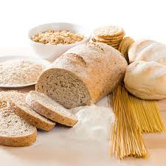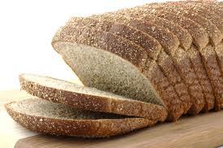

What are the benefits of choosing whole grains?

- Whole grains contain more fiber. Fiber helps with digestion, constipation, and staying full longer.
- Whole grains are packed with vitamins and minerals that are good for your health.
- Nutrients found in whole-grains helps to lower your risk for some diseases and health conditions such as high cholesterol, heart disease, and certain cancers.

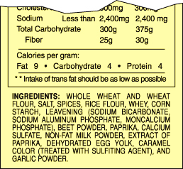
How do I know what foods are whole grain?
-Look for the words, “whole grain”, “whole wheat”, or “whole-wheat white” on the ingredient list instead “bleached” or “enriched white flour”.

-“Whole-wheat white” is made with a different kind of grain, giving it a softer texture.

-Enriched grains, for example white flour, are more processed and are missing many nutrients and fiber found in whole grains.

-Oats, wild rice, barley, buckwheat, rye, bulgur, corn, and popcorn are all great sources of whole grains!

How can I incorporate more whole grains into my day?
-Choose multigrain crackers & top with peanut butter, tuna, or low-fat cheese.
-Add brown rice or whole barley to soups or stews.
-Incorporate whole wheat pasta into delicious inexpensive lasagna.
-Start your day with oats and low-fat milk topped with dried fruit, nuts, & cinnamon.
-Choose whole grain or whole wheat bread, buns, or wraps for a nutritious sandwich or burger.
-Microwave a bag of low-fat popcorn for a whole grain late night snack!

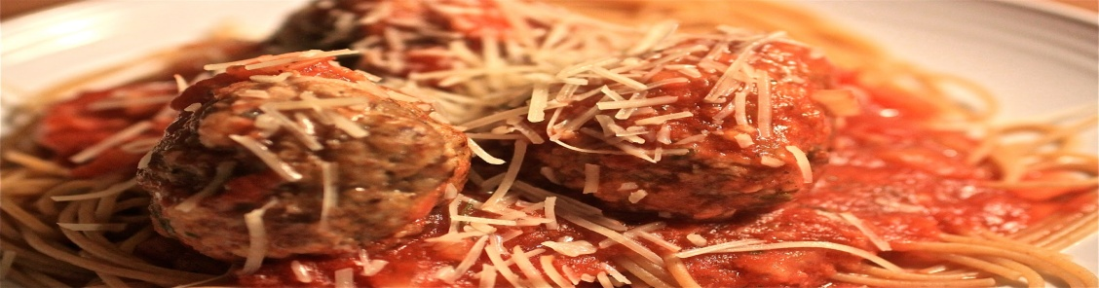

Quick and Delicious Whole-Wheat Pasta with Chunky Tomato Sauce and Turkey Meatballs
Yields: 6 servings
1 serving: 1 1/3 cups pasta and sauce, 2 meatballs

Sauce
Starting by filling a large stockpot with water and bring to a boil for pasta.
Sauce:
1. In a saucepan, heat the oil over medium heat.
2. Dice onions and pepper and cook until soft, about 3 minutes.
3. Add the chopped garlic and cook for another minute.
4. Add the can of tomatoes & basil. Bring all the ingredients to a low boil,
lower heat and cook for approximately 15 minutes.
5. Season with salt and pepper, to taste. While sauce is cooking, make meatballs.

Meatballs:
1. Preheat the broiler. Spray a baking sheet with cooking spray.
2. Combine the turkey with all other ingredients in a large bowl.
Form into 2 1/2 -inch balls and place on a baking sheet.
3. Broil for 10 minutes, or until browned and almost entirely cooked through.
4. Add the meatballs to the sauce, cover, & cook additional 10 minutes,
or until sauce has slightly thickened and meatballs have absorbed some of the sauce. While the meatballs are cooking, cook the whole-wheat pasta according to package directions.
5. Drain the pasta and add sauce. Top with 2-3 meatballs and parmesan cheese (optional)

1 Tablespoon olive oil
1 medium onion
½ medium green pepper
2 garlic cloves
1 (28-ounce) can crushed tomatoes
1 tsp dried parsley
1 tsp dried basil
Salt & Pepper to taste

Meatballs
1 pound ground turkey
½ cup bread crumbs
¼ cup Parmesan cheese
1 egg (beaten)
Black pepper to taste
1 box (16 ounces) whole-wheat pasta
(Your choice!)

*All fresh ingredients can be
purchased with Foodland voucher.

