Lowering your Blood Pressure with Lifestyle Changes
1. Maintain a Healthy Weight
- A healthy weight helps to reduce cardiovascular disease, heart attack, and stroke risk by lowering blood pressure, LDL-cholesterol, triglycerides, and percent body fat.
- Aim for 1-2 pounds of weight loss each week. For other tips on how to achieve or maintain a healthy weight, visit the National Heart Lung and Blood Institute.

2. Adopt the DASH diet
- Dietary Approach to Stop Hypertension is an eating plan recommended by the U.S. Department of Health and Human Services to prevent and control high blood pressure. The DASH diet is characterized by:

  - ↑ Potassium, Calcium, Magnesium
  - ↑ Fruits & vegetables
  - ↑ Low-fat dairy products
  - ↓ Fat, saturated fat, & cholesterol

3. Increase Physical Activity
- Aerobic physical activity-walking, jogging, swimming, biking, tennis
- 150 min every week of moderate intensity OR 75 min every week of vigorous intensity
- For specific recommendations and tips on how to increase your physical activity, visit the Centers for Disease Control and Prevention website
4. Lower Sodium Intake
- Excess salt also increases risk for kidney disease, stomach cancer, and calcium bone loss
- Goal:
  - 2,300 mg sodium/day for average population
  - 1,500 mg sodium/day for individuals at risk for heart complications (i.e. high blood pressure). Individuals with a sodium intake of 1,500 mg/day show the greatest reduction in blood pressure
- Tips
- 1 tsp salt = 2300 mg sodium
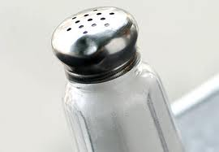
- Remove the salt shaker from the kitchen table
- Rinse canned food products-beans, corn, peas
- Limit convenience foods- deli meats, canned soup, instant oatmeal
- Read labels: ≤140 mg = low sodium food

5. Limit Alcohol & Smoking
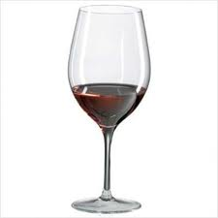
- Men ≤ 2 drinks/day
- Women ≤ 1 drink/day
  - 12 oz beer
  - 5 oz wine
  - 1.5 oz 80 proof whiskey

**Lifestyle modifications can reduce your blood pressure by 20 mmHg (standard measurement unit for blood pressure readings). For the complete report on “Prevention, Detection, Evaluation, and Treatment of High Blood Pressure”, visit <http://www.nhlbi.nih.gov/guidelines/hypertension/jnc7full.pdf>

